
Sri Lanka Institute of Information Technology

Lab Submission
<Labsheet No 8>

<IT24101931>
<Hettiarchchige G.D.P>

Probability and Statistics - IT2120
B.Sc. (Hons) in Information Technology
1)
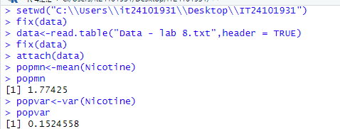
2)
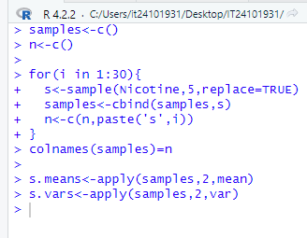
3)
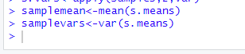
4)
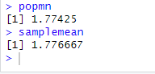
5)
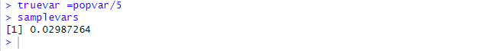
Exercise
1)
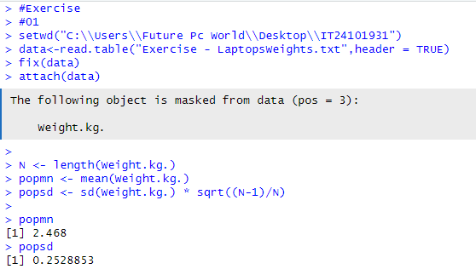
2)
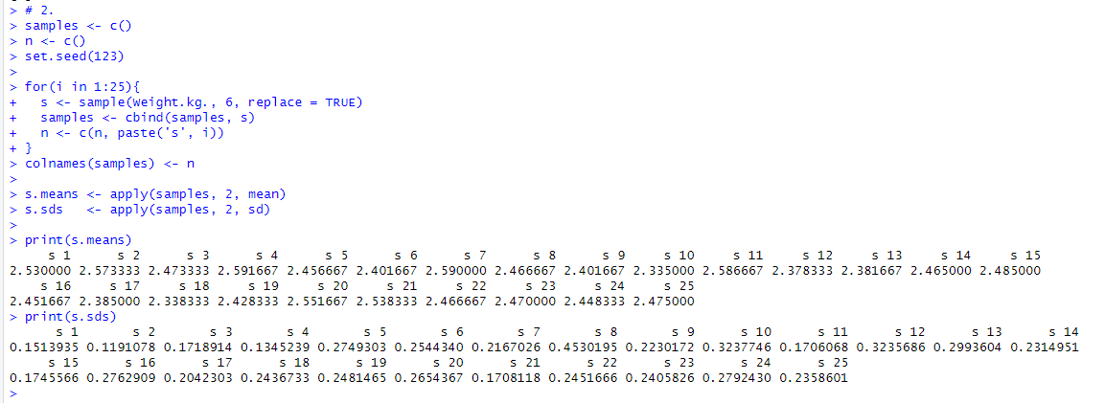
3)
